Phase 1: Literature Study, Theoretical Analysis and Initial Design
July to August, Completed
Objective: To understand the working principle and characteristics of hydraulic McKibben muscle actuators and establish the theoretical basis for actuator design.
Activities
- Studied the McKibben muscle working principle.
- Conducted literature review on pneumatic and hydraulic McKibben muscles.
- Studied the influence of internal pressure, braid angle, diameter, length, and contraction.
- Studied the influence of braided sheath geometry on actuator performance.
- Derived the pressure-force relationship, and also derived the geometrical relationship between braid angle, diameter, and actuator length.
- Studied the contraction relationship.
- Performed preliminary actuator sizing calculations.
- Prepared CAD models of the bladder, braided sheath.
- Prepared the preliminary McKibben muscle assembly.
Preliminary Actuator Parameters
Parameter | Value
Total bladder length | 300 mm
Active actuator length | 250 mm
Trial bladder diameter | 40 mm
Initial contraction range | 20% to 25%
Preliminary operating pressure | 0 to 6 bars
Required payload | Minimum 5 kg
Initial Braid Angle | 20° to 25°
Preliminary required force considered | 490.5 N
Output
- Literature review
- Theoretical derivation
- Force-pressure relationship & Contraction relationship
- Preliminary actuator dimensions
- CAD model of bladder
- CAD model of braided sheath
- Preliminary actuator assembly

Phase 2: Test-Rig Design and Commissioning
September, Week 1 to Week 2
Objective: To develop and validate a safe test setup for measuring actuator force, contraction, radial expansion, pressure response, and structural behavior.
Test Setup
The setup will include:
- Vertical actuator mounting structure
- Fixed upper mounting
- Lower moving attachment
- Load application arrangement
- Pressure supply system
- Pressure gauge or pressure sensor
- Pressure control arrangement
- Force measurement arrangement
- Linear displacement or contraction measurement
- Diameter measurement arrangement
- Safety enclosure
Test Setup Parameters
Parameter | Requirement
Actuator mounting | Vertical
Actuator alignment | Concentric and aligned with load axis
Pressure measurement | Within selected operating range
Force measurement | Suitable for expected actuator force
Displacement measurement | Suitable for expected contraction
Load application | Incremental dead weights or equivalent
Safety provision | Protective enclosure or shielding
Test specimen | Preliminary hydraulic McKibben actuator
Total actuator length | 300 mm
Active actuator length | 250 mm
Nominal trial diameter | 40 mm
Braid configuration | Cross Linking configuration
Bladder material | PU, TPU & Silicon
Working fluid | Water or hydraulic fluid
Test orientation | Vertical
Initial braid angle | 20° & 25°
Initial external load | 0 to 5kg

Activities
- Finalize vertical test rig design.
- Fabricate or assemble the test structure.
- Ensure actuator alignment with the loading axis.
- Install the pressure supply system.
- Install pressure measurement.
- Install the load application arrangement.
- Install displacement measurement.
- Prepare diameter measurement procedure.
- Prepare data recording format.
- Perform dry-run testing.
Output
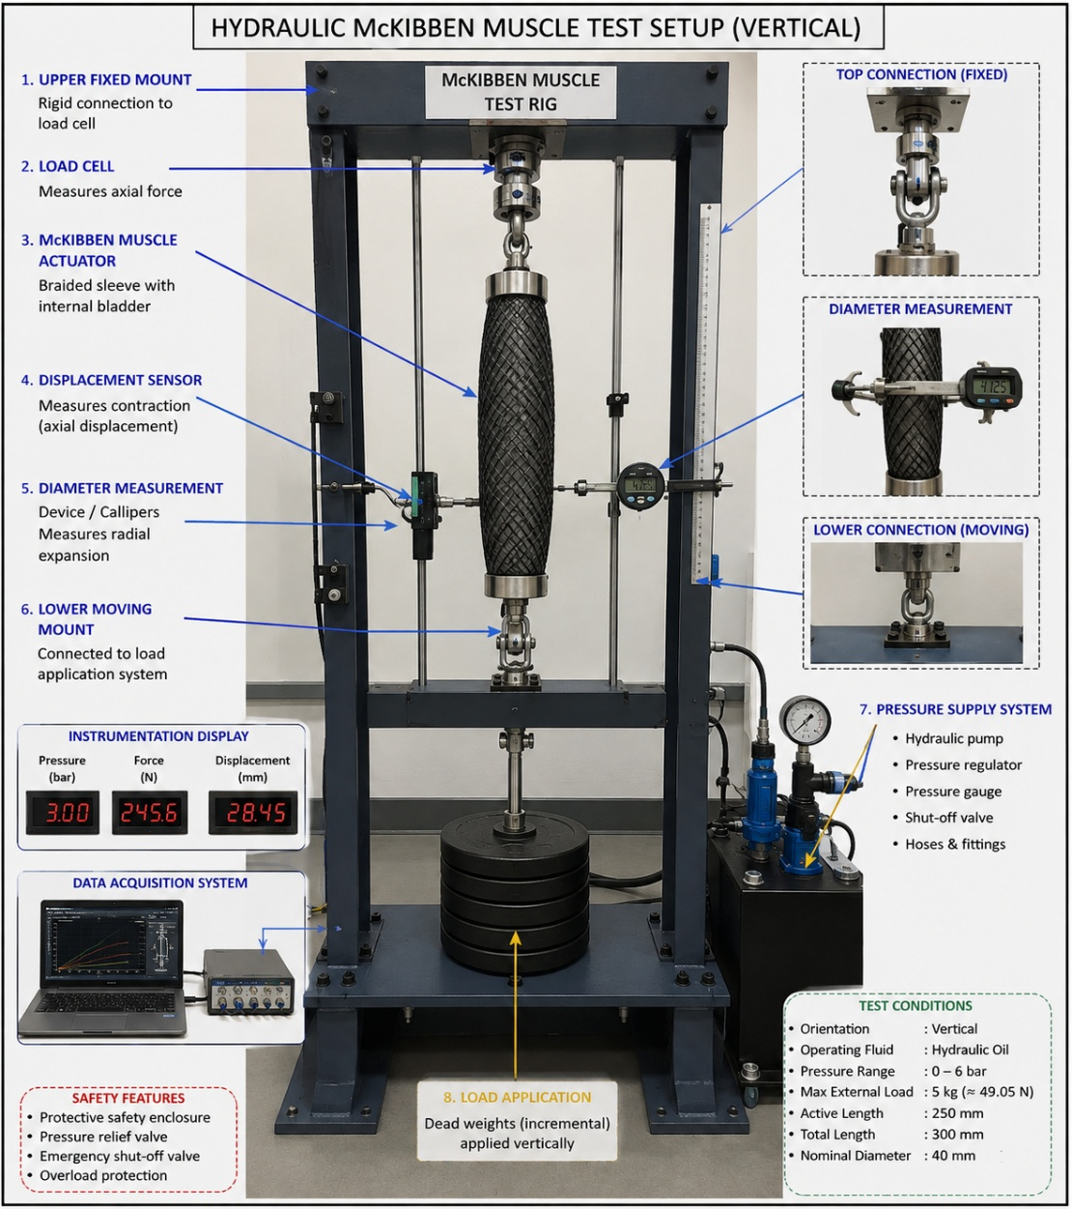
- Validated test rig
- Test setup drawing
- Instrument arrangement
- Standard test procedure
- Initial test matrix

Phase 3: Baseline Characterization and Initial Pressure Testing
September, Week 3 to Week 4
Objective: To establish the initial physical condition and pressure response of the actuator before detailed integrity testing.
Constant Parameters
Parameter | Requirement
Total actuator length | 300 mm
Active actuator length | 250 mm
Initial braid angle | 20° & 25°
Contraction Factor | 0.2 to 0.25
Nominal trial diameter | 40 mm
Braid configuration | Cross Linking configuration
Bladder material | PU & Silicon
Working fluid | Water or hydraulic fluid
Test orientation | Vertical
Initial external load | 0 to 5kg
Initial Dimensional Inspection
Parameter | Measurement
Total length | L₀
Active length | Lₐ
Outer diameter | D₀
Bladder wall thickness | t
Initial braid angle | θ₀
Braid condition | Visual inspection
End fitting condition | Visual inspection
Tests
- Dimensional inspection.
- Visual inspection.
- Initial leakage test.
- Low-pressure actuation.
- Pressure versus contraction measurement.
- Pressure versus diameter measurement.
- End-fitting stability inspection.

Pressure Test Matrix
Test ID | Pressure Level | External Load | Measurement
B1 | 0 bar | No load | Initial dimensions
B2 | 1.5 bar | No load | Length and diameter
B3 | 3.0 bar | No load | Length and diameter
B4 | 4.5 bar | No load | Length and diameter
B5 | 6.0 bar | No load | Length and diameter
B6 | 7.5 bar | No load | Length and diameter
B7 | 9.0 bar | No load | Length and diameter
Test 2: Leakage Test
Apply pressure incrementally.
Leakage Test Matrix
Test ID | Pressure | External Load | Hold Condition | Observation
B1 | 0 bar | 0 kg | Initial | Baseline
B2 | 1.5 bar | 0 kg | Hold | Leakage check
B3 | 3 bar | 0 kg | Hold | Leakage check
B4 | 4.5 bar | 0 kg | Hold | Leakage check
B5 | 6 bar | 0 kg | Hold | Leakage check
Measurements
- Pressure
- Actuator length
- Contraction
- Diameter
- Leakage
- Visible deformation
Output
- Baseline actuator specification
- Initial pressure-contraction curve
- Pressure-diameter curve
- Initial leakage condition

Phase 4: Elastic Integrity Validation
October, Week 1 to Week 3
Objective: To determine the elastic deformation, recovery, hysteresis, repeatability, and residual deformation characteristics of the McKibben muscle.
Constant Parameters
Parameter | Requirement
Total actuator length | 300 mm
Active length | 250 mm
Nominal diameter | 40 mm
Actuator configuration | Same selected configuration
Working fluid | Same selected fluid
Test orientation | Vertical
External load | No load for primary elastic test
Test 1: Pressure-Deformation Test
Apply pressure in controlled increments and measure the actuator response.
Test 1: Pressure Versus Contraction
Test ID | Pressure | Initial Length | Contraction
E1 | 0 bar | L₀ | 0%
E2 | 1.5 bar | L₀ | Calculate
E3 | 3 bar | L₀ | Calculate
E4 | 4.5 bar | L₀ | Calculate
E5 | 6 bar | L₀ | Calculate
Contraction:
ε = (L0 − L) / L0 × 100
Test 2: Radial Expansion
Test ID | Pressure | Initial Diameter | Pressurized Diameter | Radial Change
R1 | 0 bar | D₀ | D | 0
R2 | 1.5 bar | D₀ | D | Calculate
R3 | 3 bar | D₀ | D | Calculate
R4 | 4.5 bar | D₀ | D | Calculate
R5 | 6 bar | D₀ | D | Calculate
Test 3: Loading and Unloading Test
Apply pressure incrementally up to the selected maximum operating pressure.
Then reduce the pressure through the same levels.
Apply: 0 → 1.5 → 3 → 4.5 → 6 bar
Then: 6 → 4.5 → 3 → 1.5 → 0 bar

Measure:
- Pressure
- Contraction
- Diameter
- Recovery
Test 4: Elastic Recovery Test
After complete depressurization, measure:
- Final length
- Final diameter
- Residual axial deformation
- Residual radial deformation
Test 5: Repeatability Test
Repeat selected loading and unloading cycles.
Suggested initial test sequence:
Test | Number of Cycles
R1 | 5
R2 | 10
R3 | 25
R4 | 50
Measurements
Maximum contraction, Maximum diameter, Final recovered length, Final recovered diameter, Residual deformation, Variation between cycles
Output
- Pressure versus contraction curve
- Pressure versus diameter curve
- Loading and unloading curve
- Hysteresis curve
- Elastic recovery results
- Residual deformation results
- Repeatability data

Phase 5: Structural Integrity Validation
October, Week 4 to November, Week 2
Objective: To determine the structural stability and safe operating condition of the complete hydraulic McKibben muscle.
Constant Parameters
Parameter | Requirement
Total actuator length | 300 mm
Active length | 250 mm
Nominal diameter | 40 mm
Actuator configuration | Selected configuration
Test orientation | Vertical
Maximum operating pressure | 6 bar
Actuator alignment | Concentric
Inspection | Before and after each test
Test 1: Pressure Ramp Test
Increase pressure gradually.
Increase pressure from 0 to 6 bar.
Pressure levels: 0, 1.5, 3, 4.5, 6 bar.
Observe:
- Bladder expansion
- Local bulging
- Braid movement
- Braid slippage
- Leakage
- End-fitting movement
Test 2: Pressure Holding Test
Maintain selected pressure for a predetermined duration, atleast 5-10 secs.
Pressure Hold Matrix
Test ID | Pressure Level | Hold Condition | Measurements
S1 | 3.0 bar | Selected duration | Pressure decay, deformation
S2 | 4.5 bar | Selected duration | Pressure decay, deformation
S3 | 6.0 bar | Selected duration | Pressure decay, deformation

Test 3: External Load Test
Apply incremental external loads to the unpressurized and pressurized actuator where applicable, from 0 to 5kg load.
Load Matrix
Test ID | External Load | Equivalent Force
L1 | 0 kg | 0 N
L2 | 1 kg | 9.81 N
L3 | 2 kg | 19.62 N
L4 | 3 kg | 29.43 N
L5 | 4 kg | 39.24 N
L6 | 5 kg | 49.05 N
Test 4: Combined Pressure and Load Test
Apply pressure while the actuator is subjected to an external load.
Test each load at selected pressure levels.
Pressure | Load Range
1.5 bar | 0 to 5 kg
3 bar | 0 to 5 kg
4.5 bar | 0 to 5 kg
6 bar | 0 to 5 kg
Measure: Pressure, Force, Contraction, Diameter, Leakage, Structural deformation
Post-Test Inspection
Inspect:
- Bladder
- Braided sheath
- End fittings
- Braid slippage
- Braid fraying
- Local bulging
- Leakage points
- Permanent deformation
Output
- Structural integrity assessment
- Safe operating condition
- Pressure and load limits
- Structural failure observations
- Post-test dimensional comparison
Phase 6: Force-Contraction Characterization
November, Week 3 to Week 4
Objective: To experimentally determine the relationship between pressure, force, external load, and contraction.
Constant Parameters
Parameter | Requirement
Total actuator length | 300 mm
Active length | 250 mm
Nominal diameter | 40 mm
Actuator configuration | Selected configuration
Test orientation | Vertical
Pressure range | Selected validated range
Test Conditions
External Load Matrix
Pressure Level | No Load | 1 kg | 2 kg | 3 kg | 4 kg
0 bar | Test | Test | Test | Test | Test
1.5 bar | Test | Test | Test | Test | Test
3.0 bar | Test | Test | Test | Test | Test
4.5 bar | Test | Test | Test | Test | Test
6.0 bar | Test | Test | Test | Test | Test
Tests: Free contraction test, Loaded contraction test, Force versus pressure test, Contraction versus pressure test, Blocked-force test, if the rig and sensor arrangement support it.
Measurements: Pressure, Generated force, External load, Actuator length, Contraction, Diameter
Output
- Force versus pressure curve
- Contraction versus pressure curve
- Force versus contraction curve
- Load versus contraction curve
- Experimental and theoretical comparison

Phase 7: Cyclic and Endurance Testing
December, Week 1 to Week 2
Objective: To evaluate the degradation of elastic and structural performance under repeated actuator operation.
Initial Conditions
Parameter | Requirement
Actuator | Selected validated configuration
Pressure | Selected operating pressure
External load | Selected load condition
Test orientation | Vertical
Measurements | Before, during, and after cycle blocks
Test Matrix
Test ID | Pressure Level | External Load | Number of Cycles | Purpose
C1 | 3 bar | 0 kg | 100 | Initial cyclic behaviour
C2 | 3 bar | Selected load | 500 | Intermediate endurance
C3 | 4.5 bar | Selected load | 1,000 | Extended cyclic behaviour
C4 | 6 bar | Selected safe load | Further cycles if time permits | Degradation evaluation
Parameters to Monitor: Maximum contraction, Generated force, Recovered length, Recovered diameter, Leakage, Braid condition, End-fitting condition, Hysteresis change
Inspection
Conduct inspection:
- Before testing
- After each cycle block
- After final cyclic testing
Output
- Cycle versus contraction curve
- Cycle versus force curve
- Performance degradation data
- Elastic degradation data
- Structural degradation data
- Failure mode observations

Phase 8: Final Validation and Proof Testing
December, Week 3
Objective: To validate the final actuator configuration after elastic, structural, and cyclic testing.
Final Actuator Parameters
Parameter | Final Value
Total length | Final measured value
Active length | Final measured value
Outer diameter | Final measured value
Wall thickness | Final measured value
Braid angle | Final measured value
Operating pressure range | Experimentally validated range
Maximum validated force | Experimental result
Maximum contraction | Experimental result
Tests
- Final dimensional inspection.
- Leakage test.
- Pressure-contraction test.
- Pressure-force test.
- Elastic recovery test.
- Short repeatability test.
- Structural inspection.
- Controlled proof-pressure test according to the finalized test procedure.
Proof Test Procedure
- Start from zero pressure.
- Increase pressure in controlled increments.
- Hold at predefined pressure levels.
- Inspect the actuator.
- Record deformation and leakage.
- Stop according to predefined safety or failure criteria.
Output
- Final validated actuator configuration
- Final operating pressure range
- Final force capability
- Final contraction capability
- Elastic integrity assessment

Phase 9: Data Analysis and Final Documentation
December, Week 4
Objective: To analyze the complete experimental data and establish the final performance and integrity characteristics of the hydraulic McKibben muscle.
Analysis
- Compare theoretical and experimental force.
- Compare theoretical and experimental contraction.
- Analyze pressure-contraction behaviour.
- Analyze pressure-force behaviour.
- Analyze radial expansion.
- Calculate hysteresis.
- Compare initial and final dimensions.
- Analyze elastic recovery.
- Analyze structural degradation.
- Analyze cyclic degradation.
- Identify failure locations.
- Identify failure modes.
Final Results
Parameter | Initial Condition | Final Condition | Change
Actuator length | L₀ | Lf | ΔL
Diameter | D₀ | Df | ΔD
Maximum contraction | Initial | Final | Change
Maximum force | Initial | Final | Change
Leakage condition | Initial | Final | Change
Braid condition | Initial | Final | Observation
Structural condition | Initial | Final | Observation
Output
- Complete test database
- Final pressure-contraction curves
- Final force-pressure curves
- Hysteresis analysis
- Elastic integrity assessment
- Structural integrity assessment
- Endurance assessment
- Failure mode analysis
- Final validated actuator specification

Summary of Phase-Wise Programme
Phase | Duration | Activity
1 | July to August | Literature study, theoretical analysis, calculations and CAD development, Completed
2 | September, Week 1 to 2 | Test-rig design and commissioning
3 | September, Week 3 to 4 | Baseline characterization and initial pressure testing
4 | October, Week 1 to 3 | Elastic integrity validation
5 | October, Week 4 to November, Week 2 | Structural integrity validation
6 | November, Week 3 to 4 | Force-contraction characterization
7 | December, Week 1 to 2 | Cyclic and endurance testing
8 | December, Week 3 | Final validation and proof testing
9 | December, Week 4 | Data analysis and final documentation

